Group 25 Webdev Project

Video Game News Site

Project Leader: Ryan Joseph

Members: Ken Wu, Xing Wei

Table of Contents

**Milestone 51-3**

**Appendix A (Milestone 1)3-4**

**Appendix B (Milestone 2)5-17**

**Appendix C (Milestone 3)18-33**

**Appendix D (Milestone 4)32-34**

**Project Milestone #5: Server Side Programming**

Developers Thoughts:

We’ve scraped the idea of comments from the website because the programming that functionality would be too large of a project for our three-man team; Instead we’re going for a forum page for our site over the comments. Coding, debugging, and testing would be a lot easier than checking to make sure that all page’s work.

URL:

Items completed For This Milestone:

Additional Work:

Key Issues:

List of objectives for the milestone:

* Rework the wireframes/ sitemap
* PHP for log-in/log-out
* PHP for deregister
* New content for our pages
* Integrate Ben’s forum page onto our site
* Fixing the validation for signup/login page
* Fix the signup button



Appendix A

**Project Milestone #1: Project Proposal**

**Video Game News Website**

Project Leader: Ryan Joseph

Members: Ken Wu, Xing Wei

**Video Game News Website Overview**

The purpose of this site is just going to be a simple video game news website. Simple in a sense that the readers will just read the important facts and none of the opinions that most gaming news sites have. It will serve the readers by saving their time by reading just the important information about video game news. An example of this is just like reading cliff notes to a movie, books, television shows, etc. The site will provide an easy to read and easy to access. It will have a simple user interface with very little clutter distracting you from the articles. Once users have created an account with the website, they can communicate with one another through our forum page. Discussing topics related, or not!, through that page.

**Website’s Overall Goal**

Our goal as a website is to grab the attention of the gamer demographic, that are ages of between 18-49 years of age, to read our video game news site. We strive to make the video game news as our sole focal point for the site, with that being said we not focusing on any sort of reviews for video games at all. We are aiming to have a rather simple interface that will be appealing to the eyes with little to no clutter on the screen. The site’s overall look will be very similar to that of Twitter’s interface. Very simple so that the readers can scroll through the site to read just the important news about video games. The site will not operate like Twitter, such as user-generated content, we’ll being using Twitter’s webpage design as our inspirational focal point.

**Sites Overall Look**

The site will look similar to that of Twitter. You can scroll down the page till you hit the bottom with nothing but videogame news. Each post will include the news article along with any type of media such as pictures, gifs, and videos to compliment the news article. We’ll have a navigator that allows you to search specific device you’re interested in. A color scheme will be natural so it doesn’t strain the eyes of the reader. The news article head will not be long.

**Similar Website Comparison**

The two sites that we will be critiquing will be Both Twitter and IGN. First one will be IGN: IGN, the website can be viewed [here](http://ca.ign.com/), is known in the video game industry as an entertainment news site that heavily focuses on video game news and reviews. It is a great site for all your entertainment news but not everyone wants to read entertainment related news. Some would prefer just going to IGN’s website for their gaming news and reviews. We aim to bring that news aspect from IGN and incorporate that onto our simple video game news website.

Twitter is another site that will be similar to our site, you can view the site [here](https://twitter.com/). It’s rather simple and easy to read interface is one of the highlights of their website and we’ll be implementing that aspect onto our site. Twitter’s interface allows the user to just endlessly scroll through their feed till the reach a certain point where it reaches the client’s devices limit. We’re aiming for our site to be similar, but ultimately, we’re going for the page oriented style for each full-written article.

**Workplan**

Our plan is to work closely together by having an open communication with one another. We will have many ways to get in contact with one another by using one of many means: BCIT’s e-mail, Discord, cellphones, and Slacks. Ryan Joseph will set-up meetings to discuss about the project and/or concerns and everyone will work together on said project during the meetings. The workload will be divided up evenly among each member of the group by assigning teach member to write news article for the website. At this time, the project leader will be the editor for the project till we find a suitable replacement. Also, each member will be assigned to a specific videogame device to work on by creating the webpage itself and its content. Each member is also responsible to design their webpage and making sure to keep it consistent with the theme of the site. Everyone will be working on the main page together.

Appendix B

**Project Milestone #2: Site Map and Page Design**

**Site Map:**

**Milestone 3:** For milestone 3 we are adding more pages to meet the requirement for that milestone. We added a release date page for the table requirement. We noticed that a lot of sites also have a site map page and we’ve decided to include that to our site as well. We’ve made changes to the site map below.

**Print layout:**

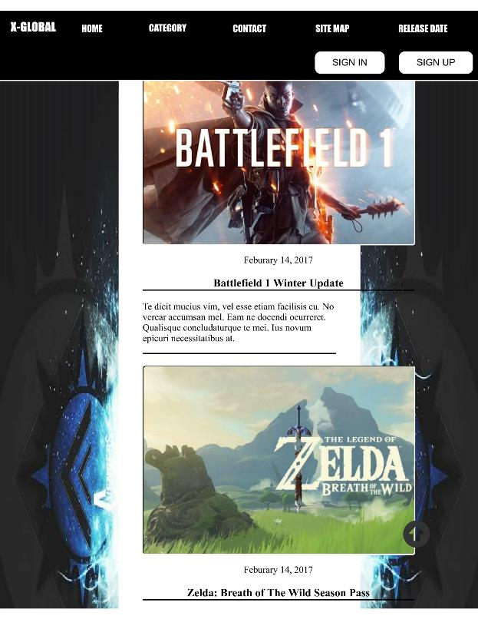

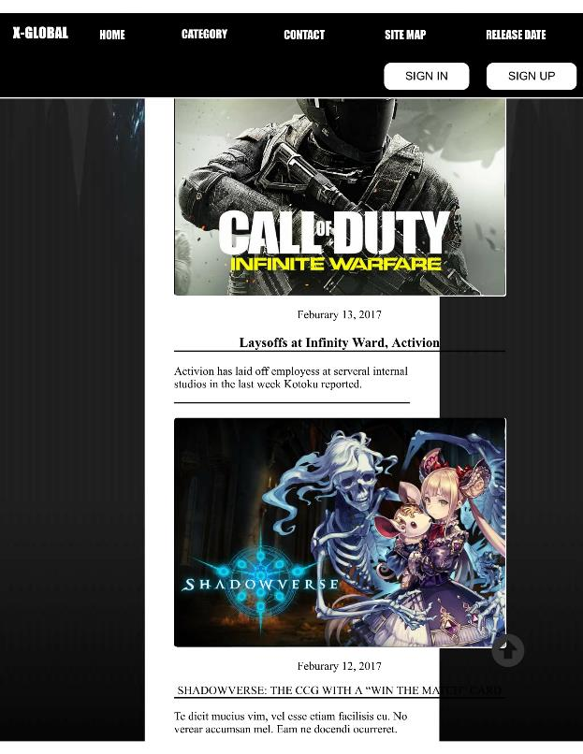



**Wireframe:**

**Milestone 4 Changes:**

With the removal of the comments from the site, we had to remove the comments from the wireframes as well to match with our current design. Only one page we forgotten to change is the release date page. Instead we’ll be implementing the forum page for our site.

The wireframes below are changed to so that the user no longer presented with a sign/sign-up page prompting the user to sign-in/sign-up. It will instead lead the user to the home page with all the gaming news. The user still can in fact still login the site by clicking the sign-in/sign-up button on the top right hand corner of the page.

Our site, at this time, will be doing a fixed position navbar. Due to the sheer scope of this project we’ll be aiming for a simple design, as stated in the proposal. The user will have to click on the image to be redirected to a separate page for a more detailed news article.

The site’s color scheme will be limited to mainly to black and white. The reason behind this is because the articles we write will include pictures/gif/videos will provide more than enough color for the site. The sites we’ve looked at, like Twitter and IGN, have very little color scheme. Trying to pick a colored background looks rather distracting for our site’s design and we’ve ultimately decided to leave it as white. The color black will be primarily for texts. We do not want very much distraction for our readers and limiting the color options will enhance the user’s experience.

**Home page:**

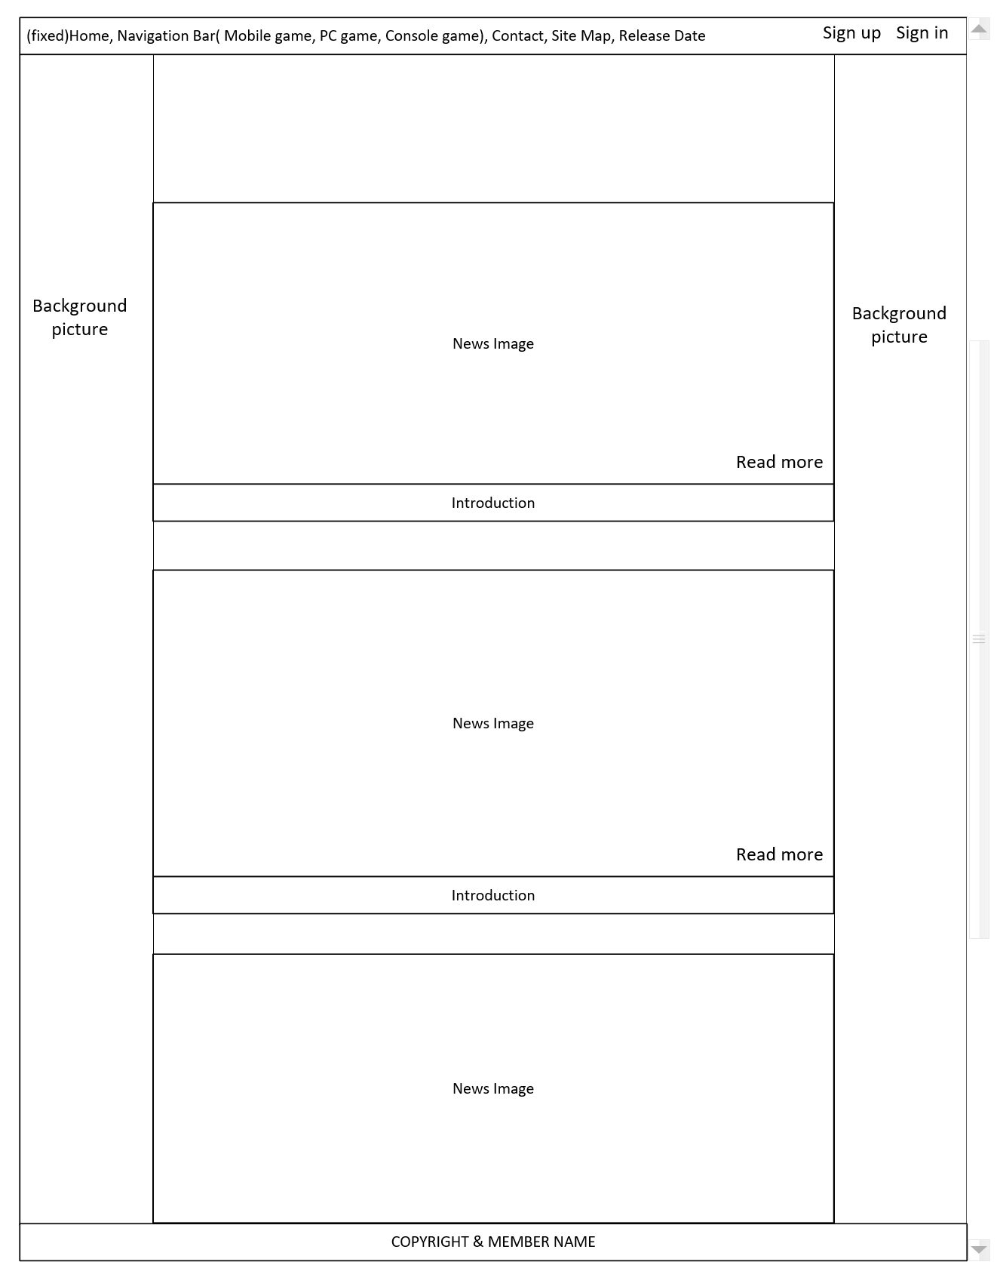

**SIGN IN PAGE (POP UP FUNTION):**

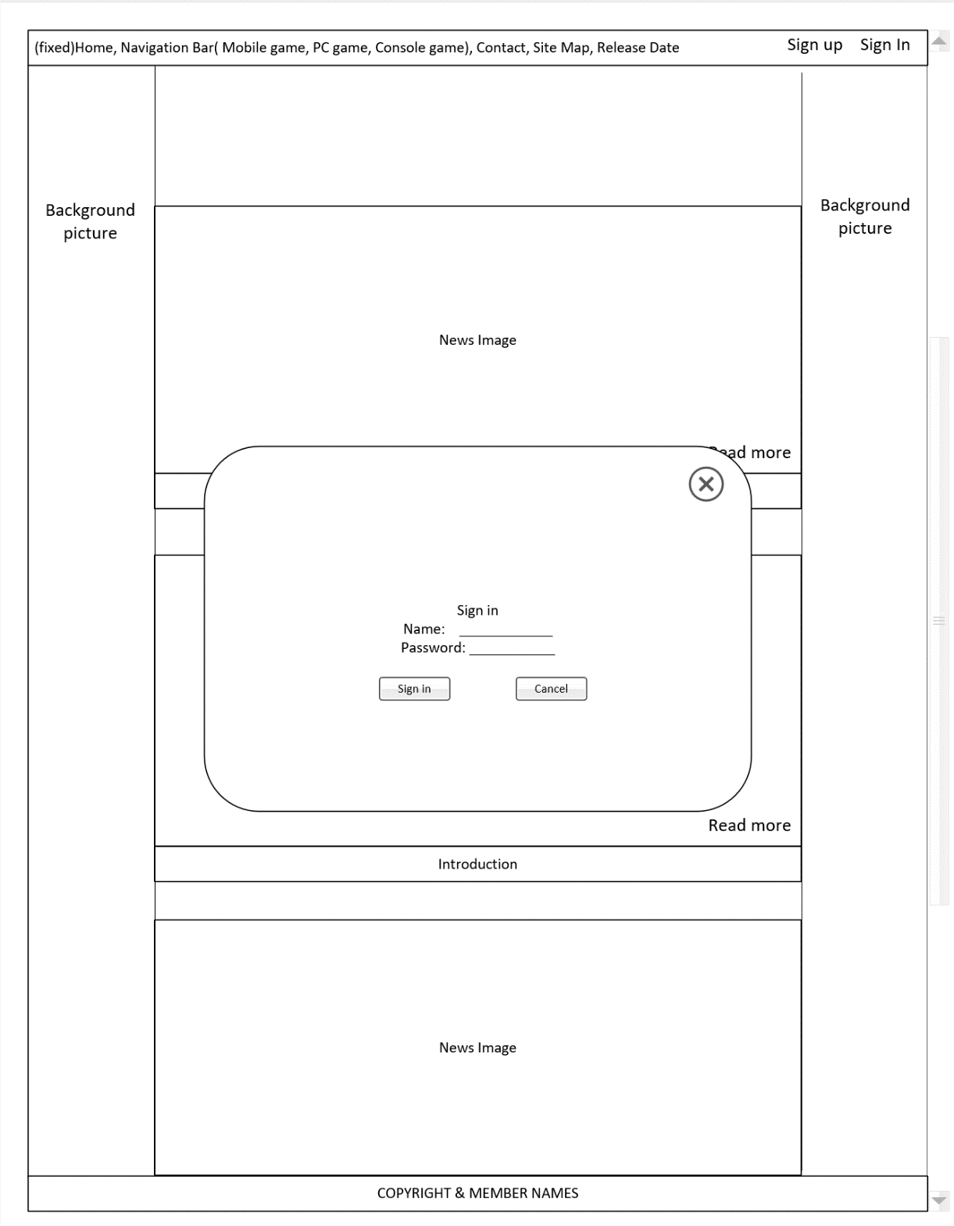

**MEMBER INTERFACE:**

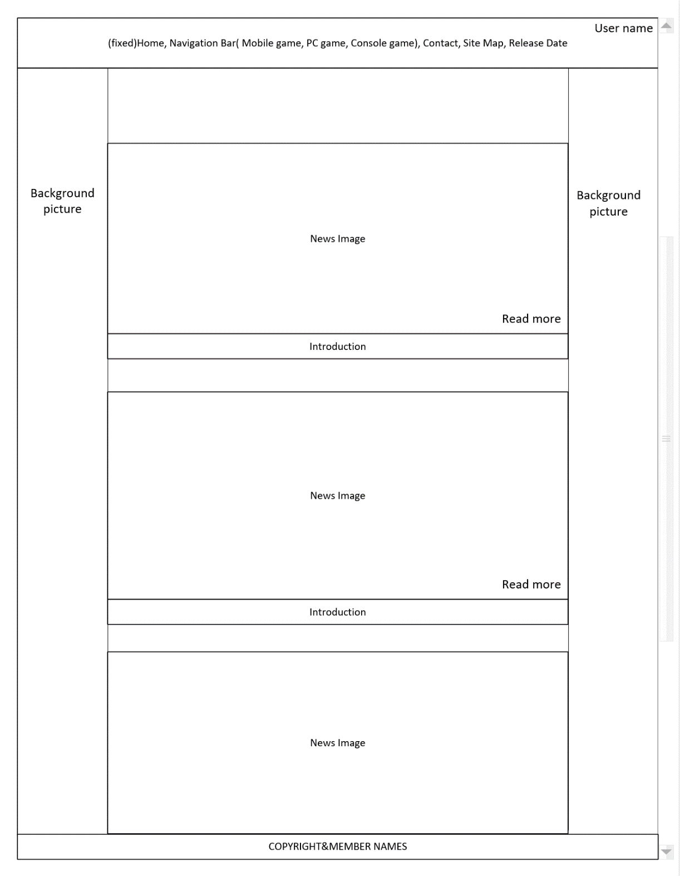

**DETAIL INFORMATION FOR SPECIFIC NEWS PAGE:**

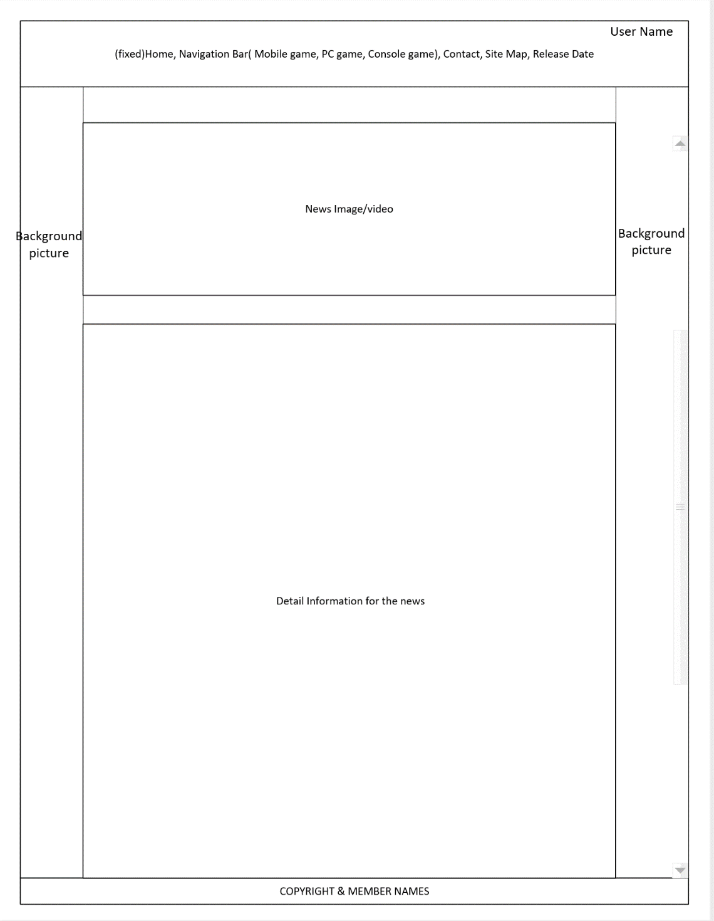

**PAGE WHEN YOU GO INTO THE SPECIFIC CATEGORY:**

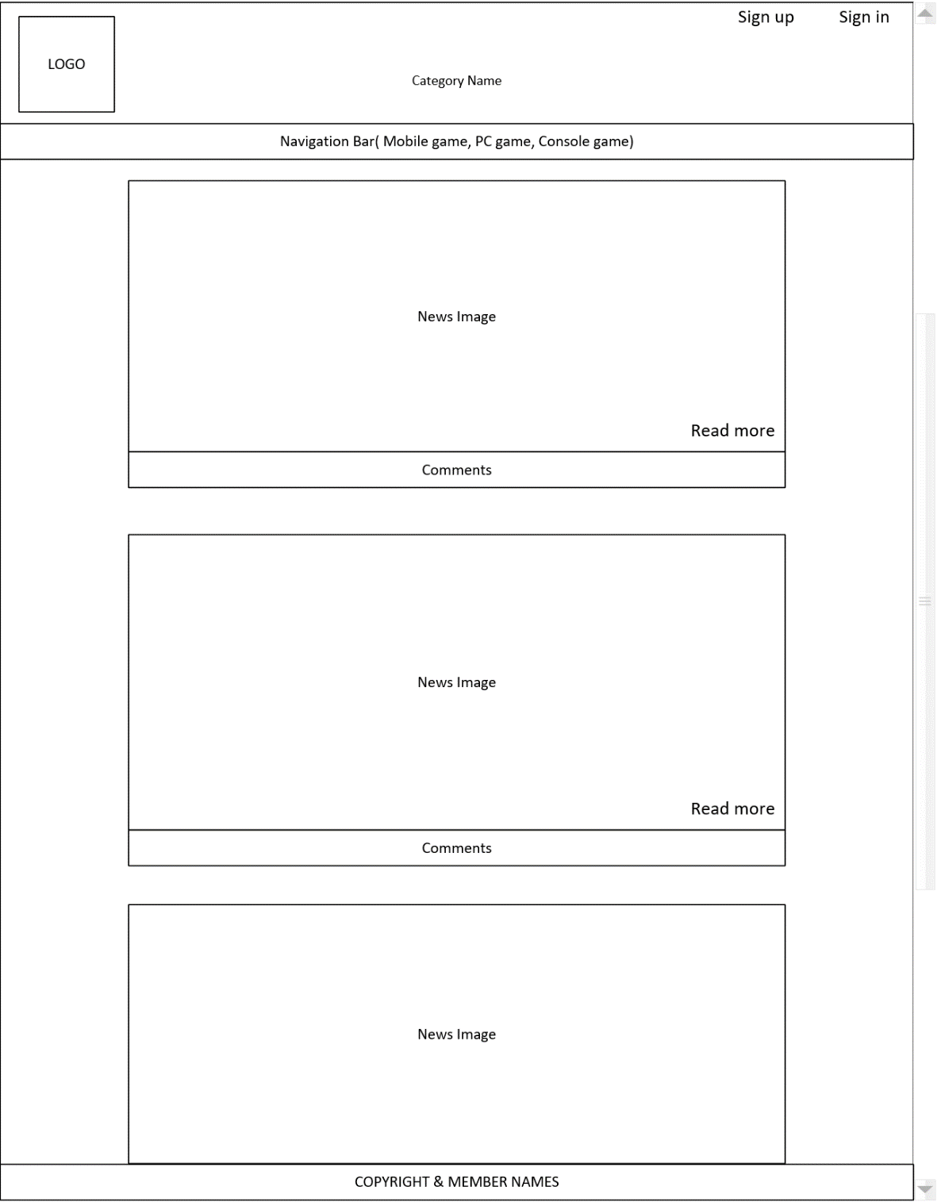

**CONTACT:**

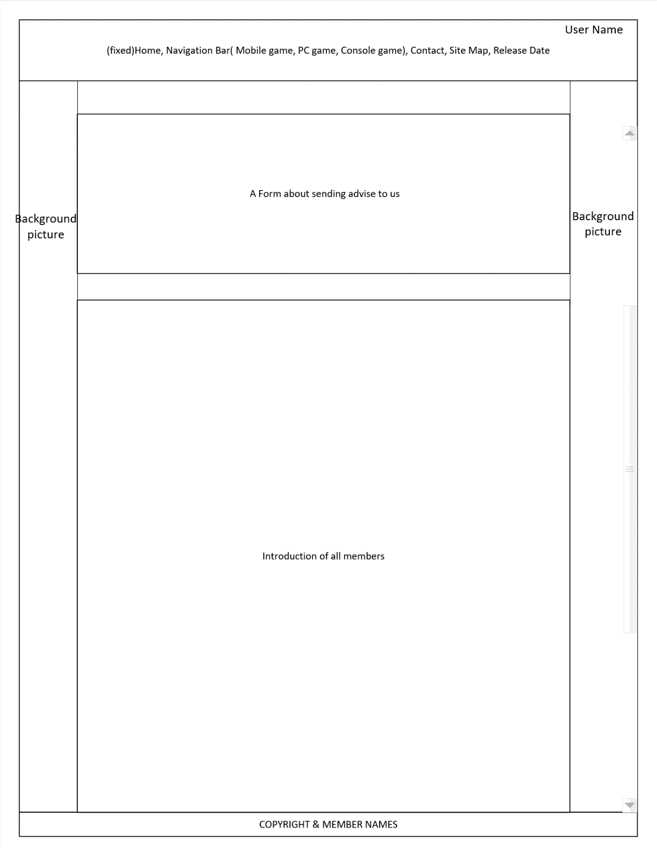

**RELEASE DATE PAGE:**

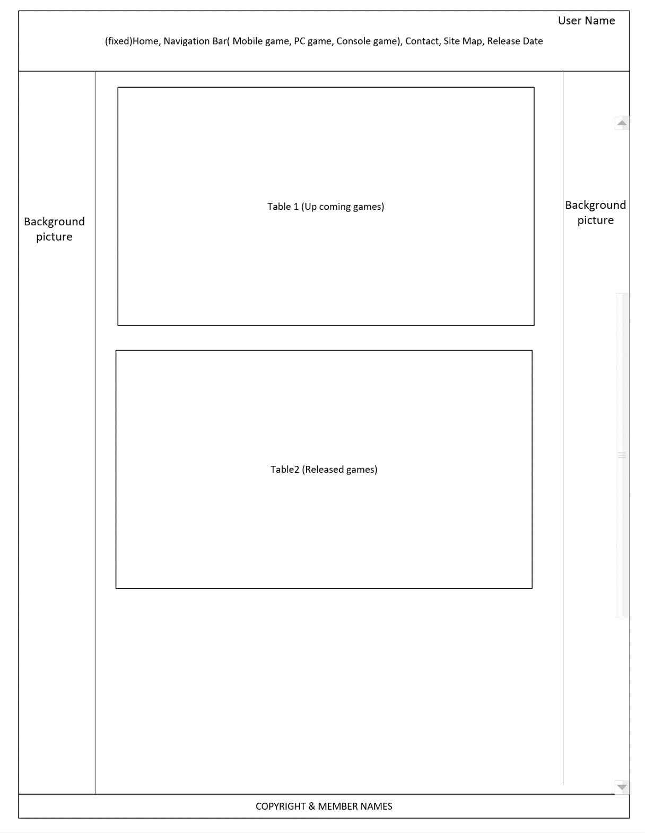

**SITE MAP:**

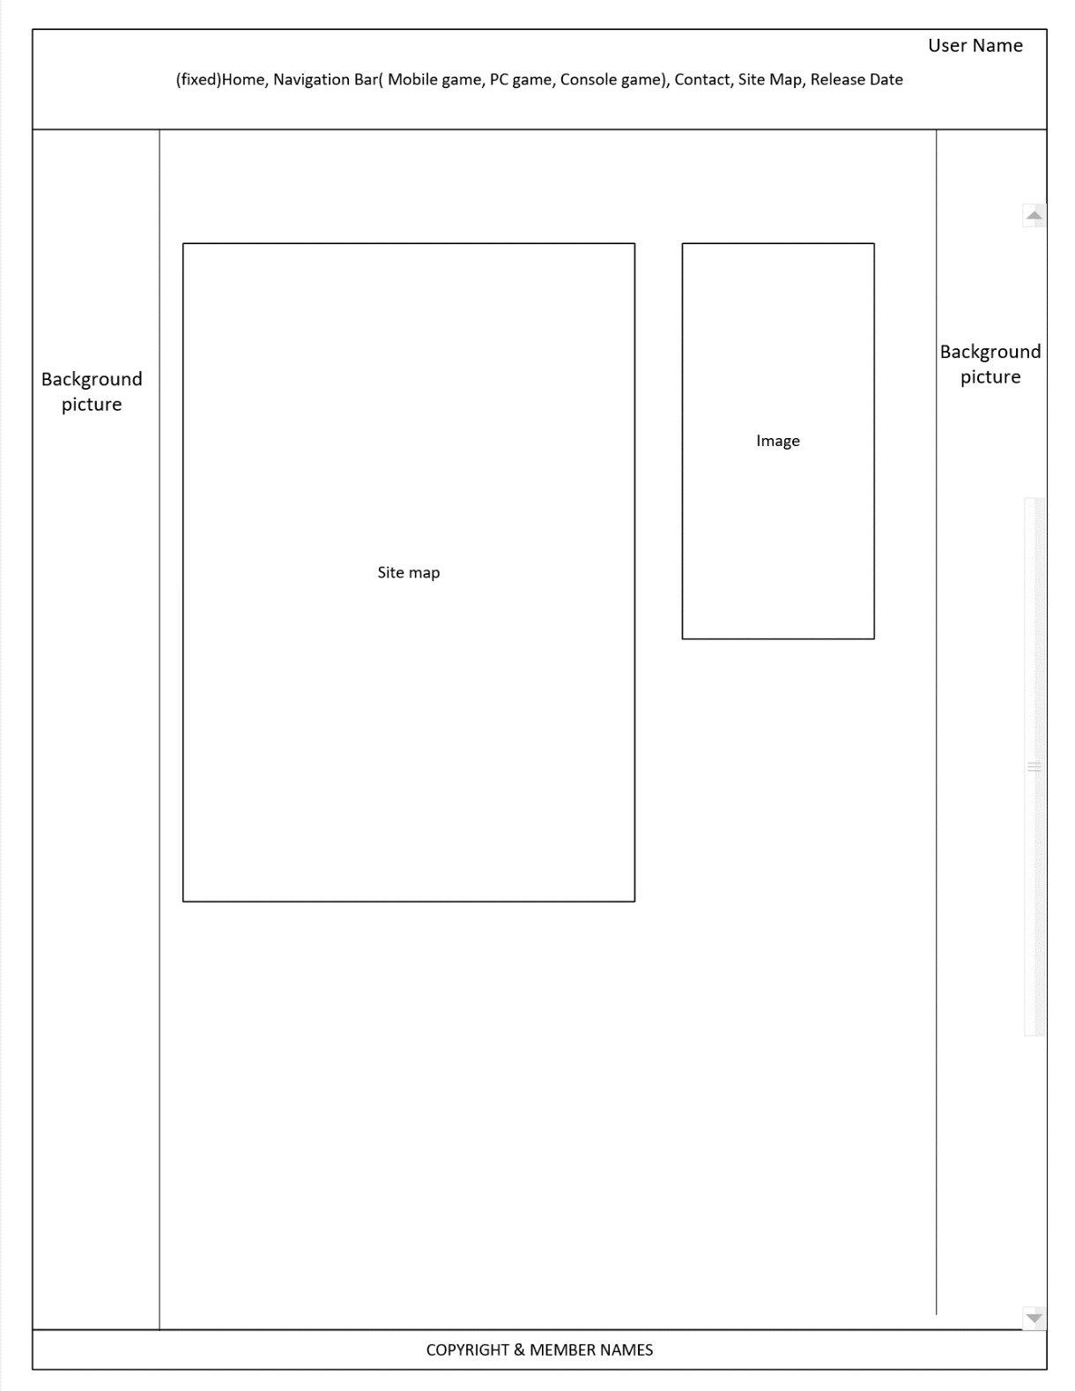

**Project Milestone #3: Skeleton site with layout, tables, and forms**

**Developers Thoughts:**

We evenly divided up the workload by assigning each person to work on two pages. We’ve managed to meet the minimum requirement for pages and we added more to the site.

The group is talking about the background of the website and deciding if it should remain white or add a background image/color.

**A/B Testing:**

Site A displays the navigation bar being static and not moving. The picture below shows the navigation bar for site A before the user scrolls down.

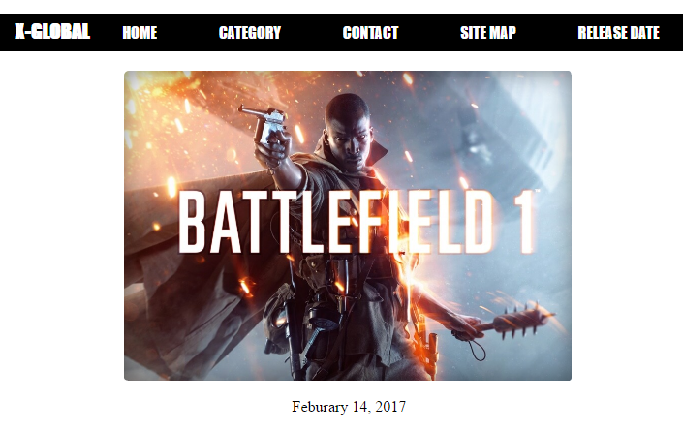

This is site A after we scroll down the page.

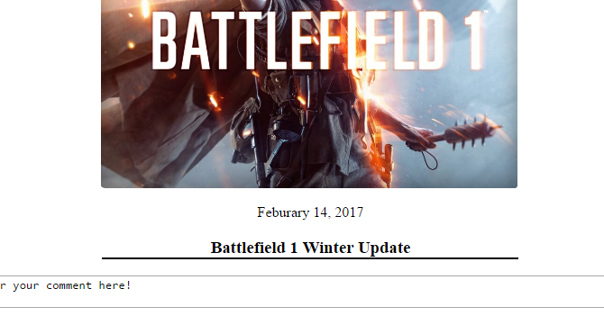

Site B shows the navigation bar being movable. For the sake of saving room, we’ll just show it in action.

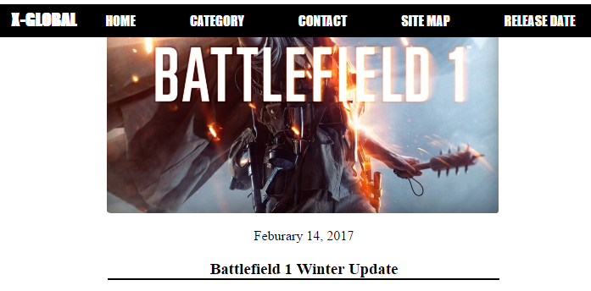

For the A/B testing the group, for the time being, decided to go with the static navigation bar. We might change from a static navigation bar to a movable one in the future, once we tidy up the site some more. We did the voting internally and it was a unanimous decision, between the three of us, that site A was a better choice. For your viewing pleasure, we’ve included site B in the files to see for yourself. It’s called “index1.html” and its css file called “index1.css”.

**Milestone 3 completed items:** Technical design, External style sheet, prototype pages, remaining pages, testing and code submission.

**Known Issues:**

* One issue is the button forms all are inconsistent with one another. This is primarily a result from using too many css files and will clean up the files in the near future.
* Another issue is the navigation bar is not consistent. The logo and the sign-in-sing-up aren’t even in the navigation bar.

**Additional Work:**

* Fixing the form buttons.
* Navigation bar needs reworking.
* Detail pages need reworking.
* Possible background rework.

**Deviations from Previous Milestones:**

We’ve added another page to the site that wasn’t in our original plan from milestone 1, which was a release date. We’ve added this to the site to meet one of the requirements for milestone 3.

Our table, which can be seen on the site called “release date” or table.html through the files.

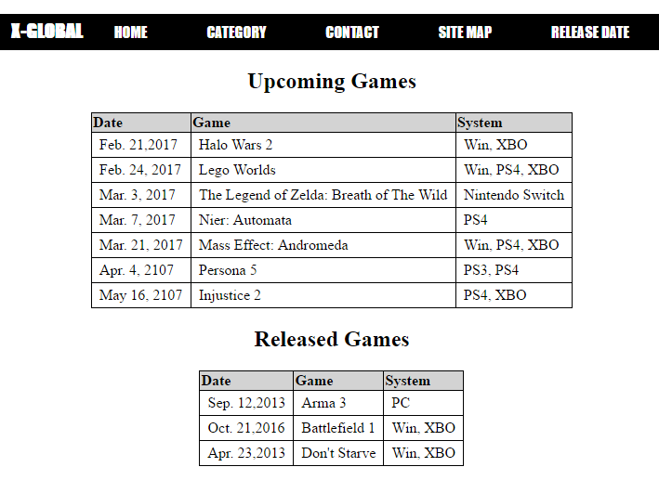

Our form sign-in.

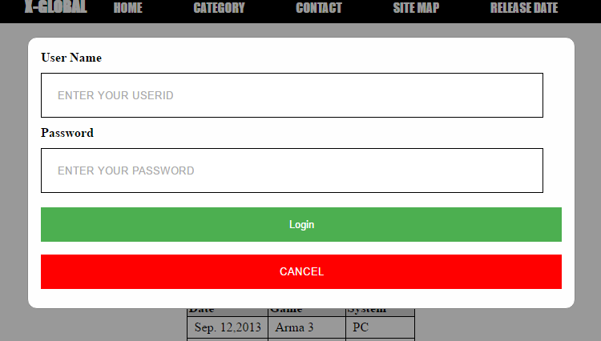

**Our base.css code**

body {

margin:0;

padding:0;

background-image: url("../images/back.jpg");

background-repeat: no-repeat;

background-size: 100% 100%;

}

header {background-color:white;}

input {

width:90%;

height:30px;

padding:12px 20px;

border:1px solid black;

margin: 10px 0;

}

#gender input {

width:10px;

height:10px;

}

.centering {text-align:center;}

.loginbutton2 {

background-color:#4CAF50;

color:white;

padding:14px 20px;

margin: 8px 0;

border: none;

cursor: pointer;

width:100%;

}

.cancelbutton {

background-color:red;

color:white;

padding:14px 20px;

margin: 8px 0;

border: none;

cursor: pointer;

width:100%;

}

.container {padding:16px;}

.modal {

display:none;

position:fixed;

z-index:1;

left:0;

top:0;

width:100%;

height:100%;

overflow:auto;

background-color: rgb(0,0,0);

background-color: rgba(0,0,0,0.4);

padding-top: 60px;

}

.modal-content {

background-color: #fefefe;

margin:10% auto 15% auto;

border-radius:12px;

border: 1px solid #888;

width:50%;

}

.button {

padding:10px 30px 10px 30px;

font-size:16px;

background-color:white;

border:2px solid black;

text-decoration:none;

cursor:pointer;

border-radius:12px;

margin:0.5em;

transition: all 0.3s ease 0.3s;

}

.button:hover {box-shadow: inset 0 0 0 5px #3071A9;}

header img {

width:65px;

height:74px;

padding:20px 0px 30px 20px;

float:left;

}

header ul {

text-align:right;

list-style-type:none;

}

nav {

z-index:1;

top:0;

position:fixed;

width:100%;

background-color:black;

clear:left;

text-align:center;

border-bottom:2px solid white;

}

.dropbtn {

color:white;

padding:10px 30px 10px 30px;

background-color:black;

font-family:Impact, Charcoal, sans-serif;

border:none;

cursor:pointer;

font-size:16px;

transition: all 0.5s;

cursor: pointer;

margin: 5px;

}

.dropbtn span {

cursor: pointer;

display: inline-block;

position: relative;

transition: 0.5s;

}

.dropbtn span:after {

content: '\00bb';

position: absolute;

opacity: 0;

top: 0;

right: -20px;

transition: 0.5s;

}

.dropbtn:hover span {padding-right: 25px;}

.dropbtn:hover span:after {

opacity: 1;

right: 0;

}

nav a {

text-decoration:none;

color:white;

font-family:Impact, Charcoal, sans-serif;

display:inline-block

}

nav strong {

color:white;

font-family:Impact, Charcoal, sans-serif;

padding-left:5px;

font-weight:bold;

font-size:20px

}

#nav_sign {

text-align:right;

float:right;

}

.button1 {

padding:10px 30px 10px 30px;

font-size:16px;

background-color:black;

border:none;

text-decoration:none;

color:white;

transition: all 0.5s;

cursor: pointer;

margin: 5px;

}

.button1 span {

cursor: pointer;

display: inline-block;

position: relative;

transition: 0.5s;

margin:0.3em;

}

.button1 span:after {

content: '\00bb';

position: absolute;

opacity: 0;

top: 0;

right: -20px;

transition: 0.5s;

}

.button1:hover span {padding-right: 25px;}

.button1:hover span:after {

opacity: 1;

right: 0;

}

.dropdown {

position:relative;

display:inline-block;

}

.dropdown-content {

display:none;

position:absolute;

background-color:black;

color:white;

z-index:1;

}

.dropdown-content a {

display:block;

color:white;

text-decoration:none;

}

.dropdown-content ul {

list-style-type:none;

padding-left:0px;

}

.dropdown-content li {

padding-top:5px;

padding-bottom:5px;

padding-left:0px;

}

.dropdown-content a:hover {

color:white;

text-shadow:0px 0px 5px white;

}

.dropdown:hover .dropdown-content {

display:block;

padding:5px 30px 5px 5px;

}

.dropdown:hover .button1 {

color:white;

text-shadow:3px 3px 3px white;

}

main {

width:50.5%;

margin-left:auto;

margin-right:auto;

padding-top:7%;

background-color:white;

}

.newsimg {

width:462px;

height:320px;

box-shadow:inset 1px 1px 40px 0 rgba(0,0,0,.45);

border-bottom:2px solid #fff;

border-right:2px solid #fff;

margin-left:auto;

margin-right:auto;

background-image:url(../images/here.png);

background-size:cover;

border-radius:5px;

overflow:hidden;

}

.cod {

width:462px;

height:320px;

box-shadow:inset 1px 1px 40px 0 rgba(0,0,0,.45);

border-bottom:2px solid #fff;

border-right:2px solid #fff;

margin-left:auto;

margin-right:auto;

background-image:url(../images/codinfinitewarfare.png);

background-size:cover;

border-radius:5px;

overflow:hidden;

}

.zelda {

width:462px;

height:320px;

box-shadow:inset 1px 1px 40px 0 rgba(0,0,0,.45);

border-bottom:2px solid #fff;

border-right:2px solid #fff;

margin-left:auto;

margin-right:auto;

background-image:url(../images/breathofthewild2.png);

background-size:cover;

border-radius:5px;

overflow:hidden;

}

.battlefield {

width:462px;

height:320px;

box-shadow:inset 1px 1px 40px 0 rgba(0,0,0,.45);

border-bottom:2px solid #fff;

border-right:2px solid #fff;

margin-left:auto;

margin-right:auto;

background-image:url(../images/battlefield1.png);

background-size:cover;

border-radius:5px;

overflow:hidden;

}

.newsimg2 {

width:462px;

height:320px;

box-shadow:inset 1px 1px 40px 0 rgba(0,0,0,.45);

border-bottom:2px solid #fff;

border-right:2px solid #fff;

margin-left:auto;

margin-right:auto;

background-image:url(../images/1.jpg);

background-size:cover;

border-radius:5px;

overflow:hidden;

}

.overlap {

width:462px;

height:320px;

background:rgba(0,0,0,.75);

text-align:center;

padding:100px 0 66px 0;

opacity:0;

transition: opacity .25s ease;

}

.newsimg:hover .overlap{opacity:1}

.newsimg2:hover .overlap{opacity:1}

.battlefield:hover .overlap{opacity:1}

.cod:hover .overlap{opacity:1}

.zelda:hover .overlap{opacity:1}

.Enter a {

font-family:Impact, Charcoal, sans-serif;

font-size:200px;

color:white;

font-size:96px;

}

.news {

width:80%;

margin-left:auto;

margin-right:auto;

border-bottom:2px solid black;

padding-top:20px;

}

.news textarea {width:100%}

.center2 {

width:462px;

margin-left:auto;

margin-right:auto;

text-align:center;

}

.center {

width:462px;

margin-left:auto;

margin-right:auto;

text-align:center;

border-bottom:2px solid black;

}

footer {

background-color:black;

text-align:center;

color:white;

height:30px;

}

footer img {

padding-left:5px;

padding-right:5px;

width:30px;

height:30px;

float:right

}

/*Scroll up function*/

.scroll-to-top-link{

position:fixed;

width:50px;

right:10%;

bottom:10%;

cursor:pointer;

}

**Project Milestone #4: Deploying JavaScript-enabled site**

**Developers Thoughts:**

This milestone, we as a group decided to scrap the whole comment aspect from our website entirely and became a regular video game news site. The reason for this is that with so many projects as of now I don’t think how we can implement this functionality onto our site in such a short amount of time.

This milestone we also wanted to make our site a little cleaner. We’ve removed the logo and moved both the sign-in and sign-up into the navbar. After much consideration, we’ve decided to go with a movable navbar after seeing the changes done. The navbar may not be finished in time for the deadline as the main focus right now is the JavaScript validation and sign-up page to go along with it.

Another change we’re making is adding another page dedicated to signing up onto our site; So, the sign-up button will no longer pop-up prompting the user to sign-in and will instead redirect the user to another page.

Right now, we are playing with an idea to have a background to our website. At the time of writing this, we’ll only have the one page so far. The verdict is still out if we want to apply a background to our site. This does step away from our original idea of having a simple layout where the article and the comments supposed to be the highlight; But, we want to replace that to make it livelier than just a black and white theme.

We asked around what the print layout is and now know what it is, I’ve gone ahead and added that to the documentation. I’ve already taken the time to indent all the CSS and HTML pages last week. I’ve made sure to tell the members to comment their code once in a while along with them indenting their pages.

**URL**

**JavaScript Validation**

|  |  |  |
| --- | --- | --- |
| **FORM on page: All the html pages. They all have the same sign-in/sign-up button functionality** | | |
| **Field ID** | **Data Format or RegExp** | **Explanation** |
| **id01** | **Type="text" for username** | **The person needs to log onto the site with a username.** |
| **Type="text" for password** | **The person needs to log onto the site with a password.** |
| **Type="submit" submit button** | **This allows the user to send their log-in info to the server.** |
| **Type="button" cancel button** | **This allows the user to cancel out of signing-on to the site.** |
| **id02** | **Type="text" for username** | **The person needs to log onto the site with a username.** |
| **Type="text" for password** | **The person needs to log onto the site with a password.** |
| **Type="submit" submit button** | **This allows the user to send their log-in info to the server.** |
| **Type="button" cancel button** | **This allows the user to cancel out of signing-on to the site.** |
| **Type="radio" male option** | **The user has an option to pick a gender when signing-up.** |
| **Type="radio" female option** | **The user has an option to pick a gender when signing-up.** |
| **Type="radio" other option** | **The user has an option to pick a gender when signing-up.** |
| **FORM on page: contact1.html** | | |
| **Field ID** | **Data Format or RegExp** | **Explanation** |
| **upperf** | **Type="text" for username** | **The person needs to enter their username so we know who we're helping with.** |
|
| **Type="email" for their email** | **We need their email address so we can contact the person, if needed.** |
|
| **Type=submit" submit button** | **This allows the user to submit their form data to our servers.** |

**3. User Test Form**

|  |  |  |  |
| --- | --- | --- | --- |
| **TEST DOCUMENTATION for FORM on page: contact1.html** | | | |
| **Student** | **Field ID** | **Problem** | **Improvements made** |
| **Ian Lo** | **upperf** | **"Your opinions" form with the text inside isn't removed when using that input. The user had to remove the text to input his text.** | **We fixed the problem by removing the text and used a placeholder instead.** |
|
|
| **Akemi Haraguchi** | **upperf** | **Once the user was finished using the form and hit submit, they were given an error page instead of the validation page.** | **We removed the link that wasn't working and replaced it with a working link.** |
|
|

**4. Javascript or jquery third party widget**

For our third-party JavaScript widget, we’ve decided to go with a scroll-up functionality onto our website because one the index.html page the user will scroll down seeing a lot of our articles. For convenience sake, we’ve made it a little easier for our user to press a button and it will auto-scroll back to the top of the page.

We’ve previously implemented a 3rd party widget and that is the Google map. We felt it was worth mentioning even though our main focus was the scroll-up button.

**Additional Work**

* Implementing the new fonts
* Centering the drop-down menu options
* Possible rework of the article page
* Adding more article links to the front page
* The document needs a bit more work

**Known Issues**

* Drop down menu items is still not centered
* Margin issues that show unintended white space on the website
* Background picture shows more white space than intended
* Mobile page is no looking the way it’s supposed too

**Completed Items for Milestone 4**

* Defined validation requirements
* Implemented validation requirements
* User test form
* 3rd party JavaScript/jQuery widgets
* Tested site without JavaScript
* Published site and tested it

End of Appendix